**HALF ADDER USING LOGISIM**

**AIM:**

To design and implement the two bit half adder using Logisim simulator.

**PROCEDURE:**

1. Pick and place the necessary gates.
2. Insert 2 inputs into the canvas.
3. Connect the inputs to the XOR gate and AND gate.
4. Insert 2 outputs into the canvas.
5. Make the connections using the connecting wires.
6. Verify the truth table.

**TRUTH TABLE:**

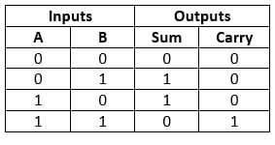

**OUTPUT**

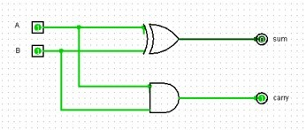

**RESULT:** Thus 2-bit half adder has been designed and implemented successfully using logisim simulator